

**PIPSTA009 – linerless label applications with Pipsta**

Each Pipsta comes complete with a roll of linerless label media. This media differs from traditional label stock in several important ways. The media:

* comes in a variety of colours,
* is continuous, so labels of any (reasonable) length can be produced,
* can be applied, removed and re-applied to surfaces many times,
* has a greater roll length than comparable label media with backing,
* has no backing-paper waste, owing to the silicone coating on the print-side,
* leaves no residue when removed.

There are many applications for this media. Consider the following non-exhaustive list:

* Sticky memos
* Name badges
* Banners for displays, noticeboards etc.
* Merits and rewards that can be transferred to wall charts
* Removable hints, scores, feedback etc. in exercise books an assignments
* Adhesive QR Codes for subsequent scanning with smart phones
* Disposable RFID/NFC tickets with bespoke print for access control, pre-pay systems etc.

 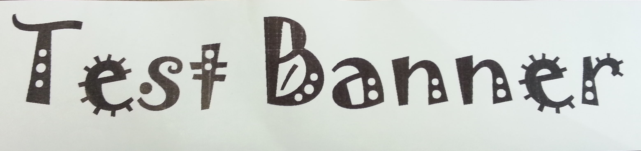 

For more information on linerless label media, its uses and demonstrations, please visit [www.pipsta.co.uk](http://www.pipsta.co.uk).

We would love to hear how you are using your Pipsta with linerless label media: tweet your application to @pipsta or visit our Pipsta Facebook page.

◼**End of Document**◼